Project Report on
Design and Implementation of a Beam-Steering Antenna Array Using Butler Matrix with 2.8 GHz operating frequency

Submitted by

ANGEL MERCY KANCHARLA – AP23110020150



Under the Guidance of
Prof. Rupesh Kumar

ECE 307 – ANTENNA DESIGN LABORATORY

DEPARTMENT OF
ELECTRONICS AND COMMUNICATION ENGNEERING,
SRM UNIVERSITY, ANDHRA PRADESH - 522240
Abstract
This report presents the complete design, simulation, fabrication, and analysis of a beam-steerable antenna array using a 4 × 4 Butler Matrix operating at the S-band frequency of 2.8 GHz. The Butler matrix, implemented using microstrip technology on a Rogers 5880 substrate, consists of key components such as branch line couplers, crossovers, and phase shifters, which are carefully designed to achieve equal power division and the required phase progression. The integrated system combines the feed network with a four-element antenna array, enabling electronic beam steering without the need for mechanical movement. The proposed design achieves an impedance bandwidth of approximately 0.6 GHz, with acceptable reflection characteristics (S11 < −10 dB) over the operating range, demonstrating good impedance matching and efficient signal transmission.
The performance of the proposed system is validated through detailed simulation results, including S-parameters, H-plane radiation patterns, surface current distributions, and far-field characteristics. The antenna array produces four distinct beams corresponding to each input port, covering an angular range of over 100°, thereby confirming effective beam steering capability. The radiation patterns exhibit stable main lobes with controlled side lobe levels, while the surface current distribution verifies proper power flow and excitation across the array elements. Although minor deviations in gain and power distribution are observed, the design maintains overall satisfactory performance. The use of a single-layer structure ensures low cost, compactness, and ease of fabrication, making the proposed antenna suitable for practical applications such as wireless communication, radar systems, and satellite tracking.
1.Introduction
Long-distance communications such as satellite communication and radar tracking applications require high-gain antennas. For this purpose, antenna arrays are used, which have a narrow beamwidth pointing in a single direction with high signal strength. Ground station satellite antennas used to track satellites in orbit, as well as radar antennas used to track objects, are typically large and heavy, making it difficult and slow to point them in different directions. One effective solution to this problem is the use of beam-steerable antennas. Beam-steerable or beamforming antennas use a set of antenna elements to focus the main beam in multiple directions either electronically or mechanically. This enables signals to be transmitted and received in one or more directions and improves overall communication efficiency.
Beamforming can be achieved either electronically or mechanically. Mechanical steering has several drawbacks. It requires complex machinery and positioning systems, which increase cost. Additionally, directing the antenna toward a specific direction is time-consuming. As a result, electronic beam steering is preferred, as it sweeps the beam direction by altering the phase of the radiating elements, producing a moving radiation pattern without any mechanical movement. This allows much faster scanning compared to mechanical steering.
Electronic beam steering can be implemented using various techniques such as the Blass matrix, Butler matrix, Rotman lens, RF phase shifters, semiconductors, and RF PIN diode switches. Each technique has its own advantages and limitations. The Blass matrix provides flexibility but is difficult to design and suffers from high losses. The Rotman lens is also complex to design. RF phase shifters and semiconductor-based methods are expensive to integrate into antenna arrays. RF PIN diode switching requires external biasing, which increases design complexity. In contrast, the Butler matrix is widely preferred because it offers a simpler design, lower cost, and nearly lossless performance.
Many research works on beam-steering antenna arrays using Butler Matrix (BM) have been reported. A compact broadband Butler matrix integrated with tunable phase shifters on a multilayer substrate has been proposed for S-band applications. Although it provides a wide beam steering range, the design becomes complex and expensive due to the use of multiple layers and integrated phase shifters.
A two-layered Butler matrix-fed antenna array has been developed for C-band applications, producing four orthogonal beams. However, the use of separate substrate layers for the feed network and antenna array increases design complexity, as coupling between layers requires additional RF components.
A monolithic 2.8 GHz Butler matrix implemented using CMOS technology has also been proposed, where the network is fabricated on a compact chip and connected to antenna elements through RF cables. Another design presents a high-gain antenna array using a Butler matrix with multiple substrate layers, including parasitic elements to enhance gain and bandwidth. While these designs are efficient and compact, the use of CMOS technology, multilayer structures, and additional components increases both cost and complexity.
A beam-steerable antenna array using substrate integrated waveguide (SIW) technology has been proposed for millimeter-wave applications, achieving high gain and wide beam coverage. However, the structure is geometrically complex. Other designs include electronically steerable antenna arrays for indoor positioning systems and multilayer beam-switching antennas for WiMAX applications. In some cases, air gaps are introduced between layers to improve performance, but this increases the antenna size.
Further developments include Butler matrices integrated with PIN diode switching circuits, wideband MIMO antenna systems with high isolation, and switched-beam antenna arrays using compact single-layer Butler matrices. Some designs achieve stable beamforming over a wide bandwidth, while others utilize SIW-based Butler matrices with modified hybrid couplers for advanced applications.
Although these existing works demonstrate good performance, they often rely on techniques such as SIW structures, multilayer substrates, CMOS technology, and air gaps, which increase design complexity and cost. In contrast, the proposed Butler matrix-based antenna design uses a low-loss, flexible, single-layer substrate, making it simpler, cost-effective, and easier to fabricate while maintaining good performance.
Initially, all components of the 4 × 4 Butler matrix feed network are designed and simulated at the required operating frequency, and then the Butler matrix is integrated with a four-element antenna array. Various antenna parameters such as reflection coefficient, gain, half-power beamwidth, radiation efficiency, and beam patterns are analyzed. Unlike many existing designs, the proposed system uses a single-layer structure, resulting in reduced complexity and improved practicality.

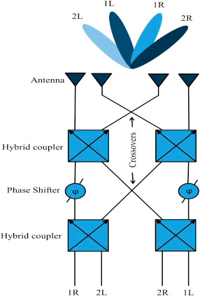
Fig. 1: Block Diagram of a 4x4 Butler Matrix

2.Butler Matrix Design
A Butler matrix is a passive beam-steering feed network used to feed antenna array elements in order to produce orthogonal beams that can be directed in different directions. It is a cost-effective solution since it can be fabricated using microstrip line technology. Additionally, it provides an efficient method for beam steering without the need for expensive active devices. The block diagram of a 4 × 4 Butler matrix is shown in Fig. 1, where the steered beams are represented with respect to the excited input port. This Butler matrix consists of four input ports and four output ports, where the antenna elements are connected to the output ports. With a progressive phase shift, the input power is equally divided into four parts by the 4 × 4 Butler matrix.
As shown in the block diagram, the branch line coupler, crossover, and phase shifter are the key components of a Butler matrix. All three components are designed on a 0.381 mm thick Rogers 5880 substrate (εr = 2.2) and are explained in detail in the following sections.

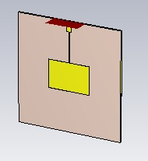
Fig 2: Microstrip Patch Antenna
2.1 Microstrip Patch Antenna
The Fig 2 shows a rectangular microstrip patch antenna, where a metallic patch (yellow) is printed on a dielectric substrate with a ground plane on the opposite side, and it is excited using a microstrip feed line. The antenna operates based on the fundamental ${TM}_{0}$ mode, where the patch length is approximately half of the guided wavelength. The resonant frequency is given by
$$f_{r}= \frac{c}{2L\sqrt{ε_{eff}}}$$
where c is the speed of light, L is the effective length of the patch, and $ε_{eff}$ is the effective dielectric constant. The effective dielectric constant is calculated as
$$ε_{eff}=\frac{ε_{r}+1}{2}+ \frac{ε_{r}-1}{2} {\left(1+12\frac{h}{W}\right)}^{-1/2}$$
where $ε_{r}$ is the substrate dielectric constant, h is the substrate height, and W is the patch width. Due to fringing effects, the effective length is slightly larger than the physical length, given by $L_{eff}$=L+2ΔL. This type of antenna is widely used because of its low profile, ease of fabrication, and compatibility with planar circuits, making it suitable for applications such as wireless communication and phased array systems.
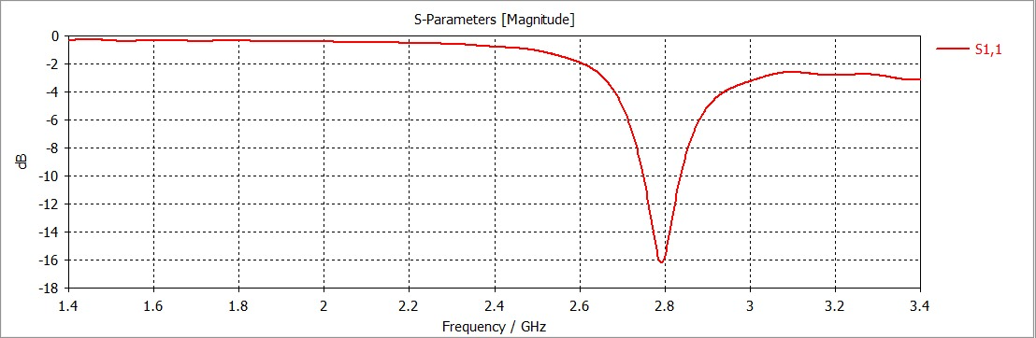
Fig 3: S parameters of patch antenna
The Fig 3 shows the S-parameter (S11) response of the microstrip patch antenna, representing the reflection coefficient versus frequency. A deep notch is observed around 2.8 GHz, where S11 reaches approximately −16 dB, indicating good impedance matching and minimal power reflection at the resonant frequency. The antenna operates effectively in the region where S11 is below −10 dB, confirming its suitability for S-band applications. Outside this region, higher S11 values indicate increased reflection and reduced efficiency.
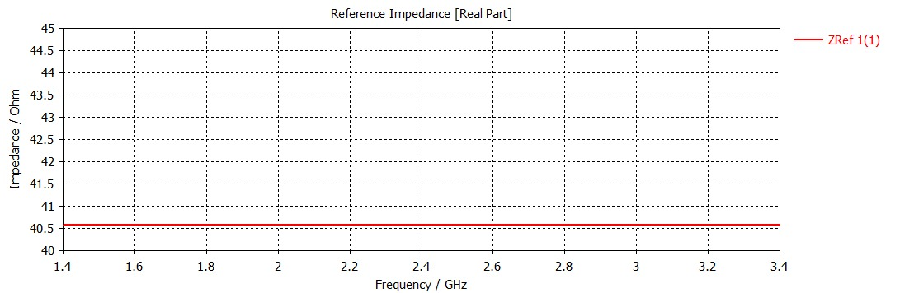
Fig 4: Reference Impedance of patch antenna
The Fig 4 shows the reference impedance (real part) of the patch antenna input over the frequency range from 1.4 GHz to 3.4 GHz. It can be observed that the impedance remains nearly constant at around 40 Ω, indicating stable input characteristics across the band. Although slightly lower than the standard 50 Ω, this value suggests reasonable impedance matching with minimal variation. The flat response implies consistent performance with low reflections over the operating frequencies. Overall, the result confirms that the antenna maintains stable impedance behavior, contributing to reliable operation.
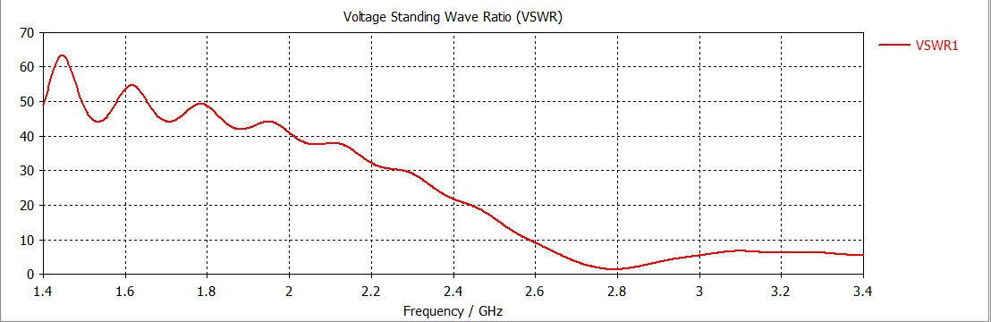
Fig 5: VSWR plot of patch antenna
The Fig 5 shows the Voltage Standing Wave Ratio (VSWR) variation with frequency for the antenna. A minimum VSWR is observed around 2.8 GHz, where the value is close to 1–2, indicating good impedance matching and efficient power transfer. At frequencies away from resonance, the VSWR increases significantly, showing higher reflections and poorer matching. The region where VSWR ≤ 2 corresponds to the effective operating bandwidth of the antenna. This confirms that the antenna performs optimally near the designed resonant frequency.
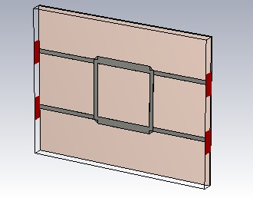
Fig 6: BLC
2.2 Branch Line Coupler
The Branch Line Coupler (BLC) is a key element of the Butler matrix. It is also known as a 3 dB or 90° hybrid coupler because it distributes power equally across the output ports with a phase difference of 90° at the operating frequency. Its ability to evenly divide power makes it an important circuit component in a wide range of applications. A BLC consists of one input port, two output ports, and one isolated port. Either port 1 or port 4 can be used as the input port. Fig. 6 shows the designed and simulated BLC at 2.8 GHz, where the 50 Ω line has a width of 1.1 mm and the 35 Ω line has a width of 1.75 mm. The quarter-wavelength line length at 2.8GHz is 7.5 mm. The impedances of the transmission lines are calculated using Eqs. (1) and (2).
W= $\frac{8he^{B}}{e^{2B}-2}$ (1)
B=$\frac{Z_{0}}{60}$ * $\sqrt{\frac{ε_{r}+1}{2}}$ + $\frac{ε_{r}-1}{ε_{r}+1}$ (0.23 + $\frac{0.11}{ε_{r}}$ (2)

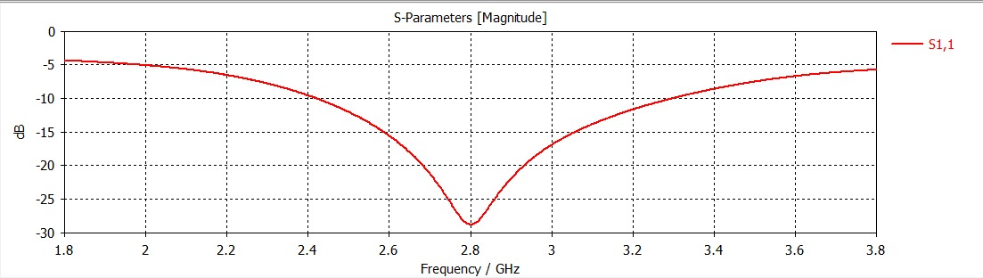
Fig.7(a): Simulation of BLC, s-parameters

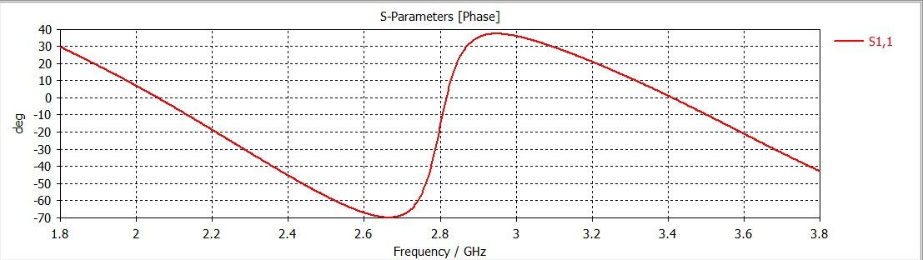
Fig.7(b): Phase difference between the output ports of BLC.
Fig. 7(a) shows the simulated S-parameters of the BLC. From the figure, it can be observed that the BLC operates over the frequency range of 1.8 to 3.8 GHz. It can also be seen that at 2.8 GHz, the S21 and S31 values are approximately −5 dB, which confirms that the designed BLC splits the input power equally between the two output ports. Fig. 7(b) shows that the phase difference between the output ports of the BLC is 89.64°, which is approximately 90°. These simulation results confirm that the designed BLC operates as expected.
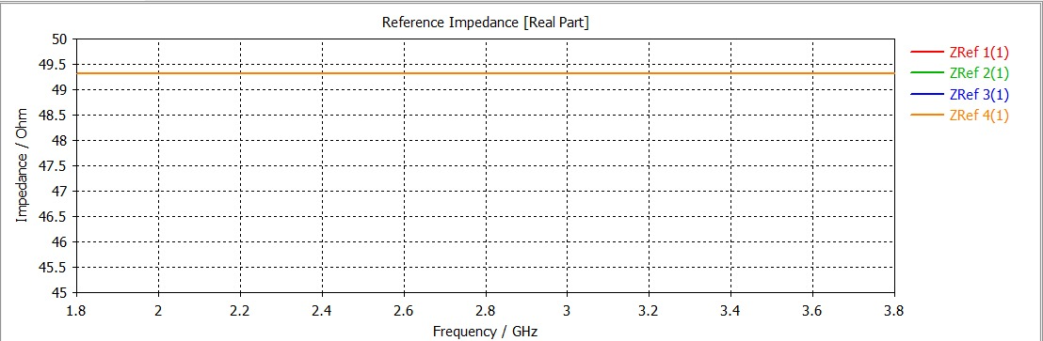
Fig 8: Reference Impedance of Hybrid Coupler
The Fig 8 shows the reference impedance of the hybrid (branch line) coupler as a function of frequency. It can be observed that the impedance remains nearly constant at around 50 Ω for all ports across the entire frequency range from 1.8 GHz to 3.8 GHz. This indicates excellent impedance matching, which is essential for minimizing signal reflections and ensuring maximum power transfer within the network. The flat response also confirms that the coupler is well-designed and stable over a wide bandwidth. Such consistent impedance characteristics contribute to the efficient operation of the Butler matrix and improve the overall performance of the antenna system.

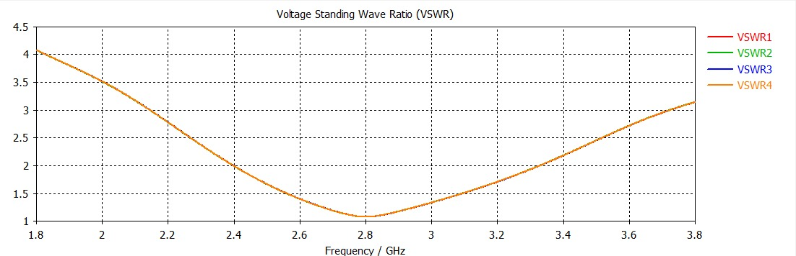
Fig 9: VSWR of coupler
The Fig 9 shows the VSWR characteristics for all four ports (VSWR1–VSWR4) of the Butler matrix integrated antenna system. It can be observed that all ports exhibit nearly identical behavior, indicating good symmetry and uniform design. The VSWR reaches a minimum value close to 1 at around 2.8 GHz, confirming excellent impedance matching at the operating frequency. As the frequency moves away from resonance, the VSWR gradually increases, indicating higher reflections. Overall, the response demonstrates stable performance and efficient operation of the system across the desired frequency range.
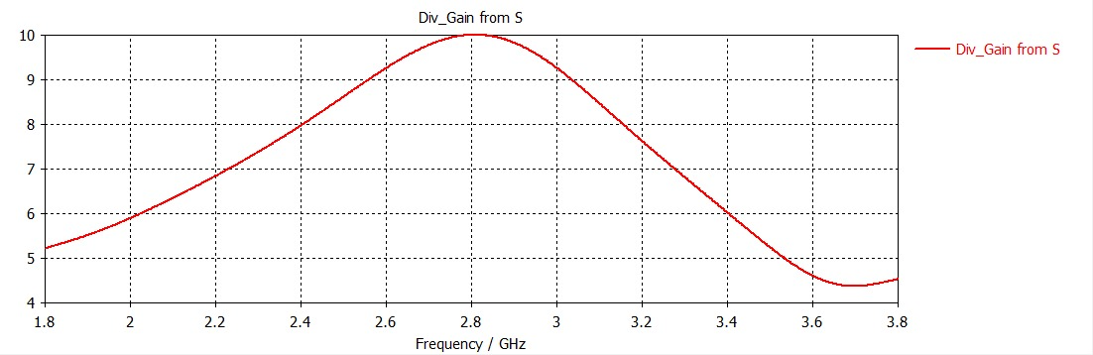
Fig 10: Gain of coupler
The Fig 10 shows the gain variation (Div_Gain from S) of the coupler with respect to frequency. It is observed that the gain increases gradually and reaches a peak of around 10 dB near 2.8 GHz, which corresponds to the designed operating frequency. This indicates efficient radiation and maximum power transfer at resonance. Beyond this frequency, the gain decreases, showing reduced performance at higher frequencies. Overall, the plot confirms that the antenna achieves optimal gain characteristics around 2.8 GHz, making it suitable for the intended application.

2.3 Crossover
The crossover is an additional element used in the Butler matrix. One of the main challenges in a Butler matrix is the overlapping of signals. To overcome this issue, a crossover with high isolation between adjacent ports is used. It can be constructed by cascading two BLCs in series. The crossover has four ports, consisting of two input ports and two output ports. This crossover operates such that when port 1 is excited, the power is first split equally by the first BLC, and then the split signals are recombined by the second BLC. As a result, the signal appears at the opposite output port.

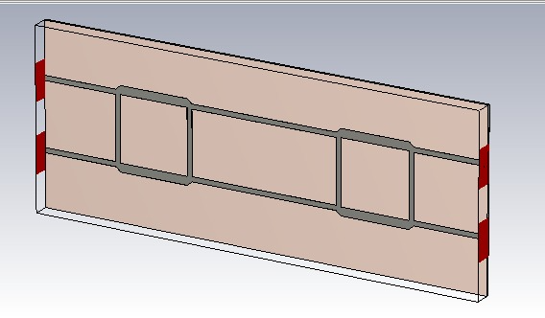
Fig.11: Crossover
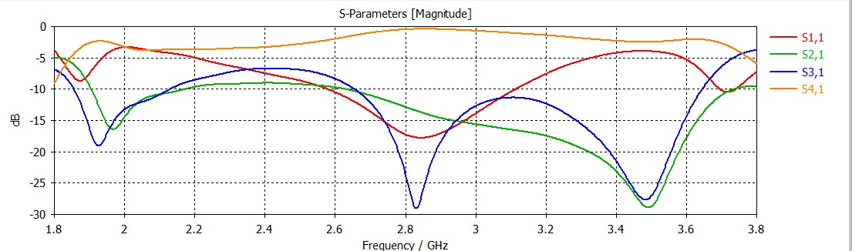
Fig.12: Simulation of s-parameters of crossover
The designed and simulated crossover at 2.8 GHz is shown in Fig. 11, and its simulated S-parameters are presented in Fig. 12. From the simulation results show that the reflection coefficient (S11) is below −10 dB over a limited frequency range of approximately 2.6 to 3.2 GHz, with a minimum value of about −18 dB near 2.85 GHz. The isolation levels indicate that S21 reaches a minimum of approximately −29 dB around 3.5 GHz, while S41 remains between −1 dB and −4 dB across most of the band. The transmission coefficient S31 varies significantly, with a maximum of about −6 dB and a deep null near −29 dB, indicating that ideal crossover behavior (≈0 dB insertion loss) is not achieved. This confirms that the power applied at port 1 is effectively transferred to port 3.

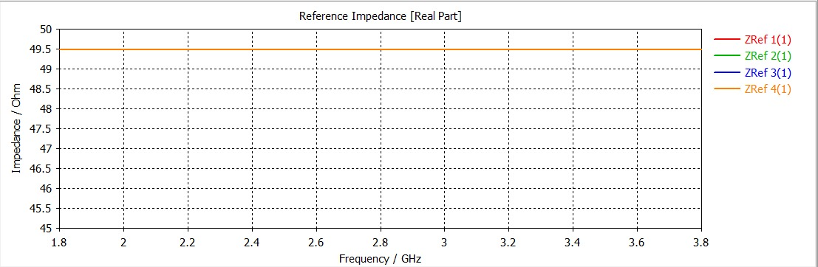
Fig 13: Reference Impedance of Crossover

The Fig 13 illustrates the reference impedance of the crossover, showing its variation with frequency over the range of 1.8 GHz to 3.8 GHz. It is evident that the impedance for all ports remains nearly constant at approximately 50 Ω, indicating excellent impedance matching throughout the operating band. This stable and uniform impedance response ensures minimal signal reflection and efficient power transfer between the interconnected transmission lines. The consistent behavior across all ports also confirms the proper design and symmetry of the crossover structure. Overall, this characteristic is crucial for maintaining the performance of the Butler matrix and ensuring reliable signal routing within the beamforming network.
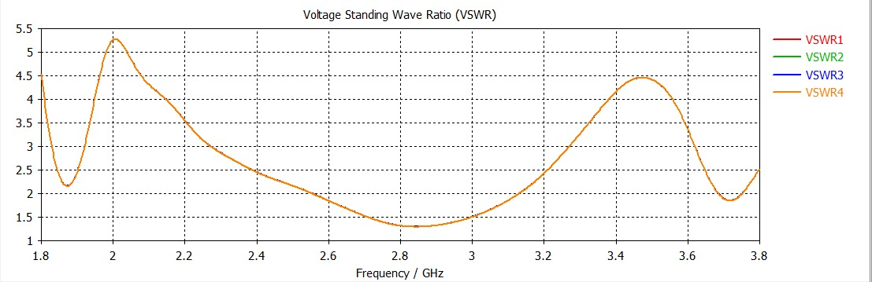
Fig 14: VSWR of Crossover
This Fig 14 shows the VSWR response of the Butler matrix integrated with the antenna, indicating how well the system is impedance matched over the frequency range. The VSWR remains relatively low (around 1.3–2) near 2.7–3.0 GHz, suggesting good matching and efficient power transfer in this region. At lower and higher frequencies, the VSWR increases, with peaks above 4–5 indicating significant mismatch and higher reflections. Overall, the plot highlights that optimal performance occurs within a limited band where the VSWR is closer to unity.
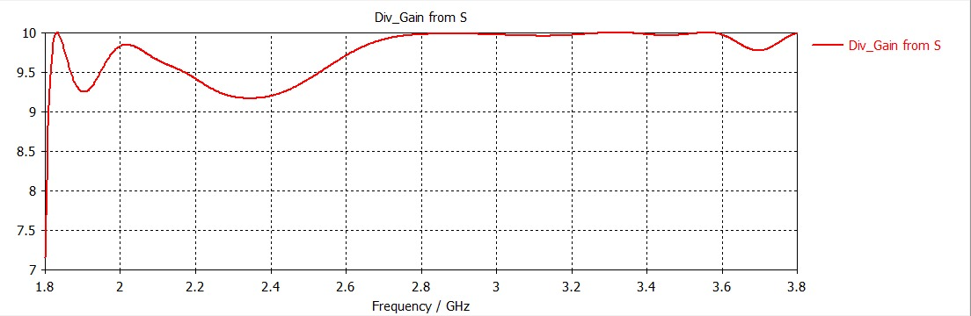
Fig 15: Gain of crossover
The Fig 15 shows the variation of “Div_Gain from S” (likely divider or system gain) as a function of frequency from about 1.8 GHz to 3.8 GHz. The gain rises sharply near 1.8 GHz, then exhibits small ripples and dips, particularly around 2.2–2.4 GHz where it slightly decreases. Beyond ~2.6 GHz, the gain stabilizes close to 10 with minimal variation, indicating a relatively flat and consistent response. A small dip appears again near 3.6–3.7 GHz, but overall the system maintains high and stable gain across most of the frequency range.
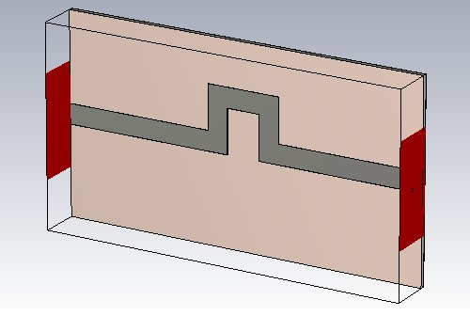
Fig.16: Designed and simulated phase shifter

2.4 Phase Sifter
A phase shifter is another important element used in the Butler matrix, which changes the phase angle of the signal passing through it. A phase shifter can be designed using microstrip technology. Any transmission line that is longer than the reference line (‘L’) by a specific length ‘ΔL’ can provide the required phase shift (θ), which is given by:
ΔL = (θ × λg) / 360
where λg is the guided wavelength, C is the velocity of light, εr is the dielectric constant of the substrate, and θ is the desired phase shift (45°).
The designed and simulated 45° phase shifter is shown in Fig. 16. As shown in the figure, ΔL is calculated to be 6 mm. Ideally, the output power of a phase shifter should be equal to the input power, indicating 0 dB insertion loss. However, due to conductor and dielectric losses, a small insertion loss may occur.
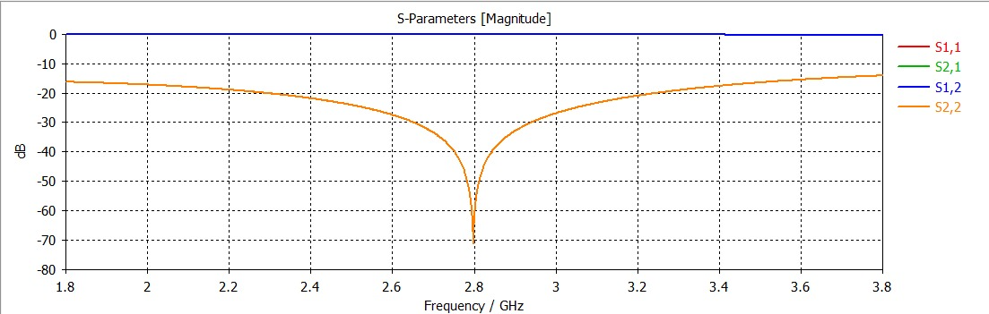
Fig.17(a): s-parameters of Phase shifter
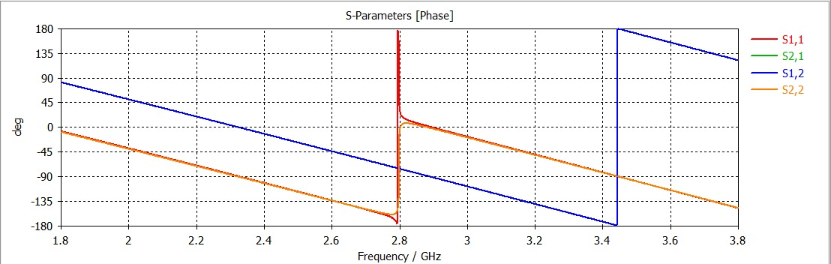
Fif.17(b): Output phase of phase shifter

Fig. 17(a) illustrates the simulated S-parameters of the phase shifter, where the reflection coefficient (S11) at 10 GHz is −25 dB and the insertion loss (S21) is approximately zero (−0.11 dB).
Fig. 17(b) shows that the phase difference between ports 1 and 2 at 10 GHz is 45°, confirming that the designed phase shifter provides the required phase shift.

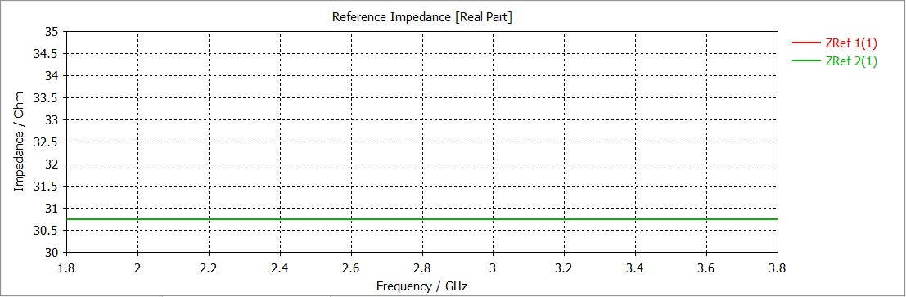
Fig 18: Reference Impedance of Phase Shifter

The Fig 18 shows the reference impedance of the phase shifter across the frequency range from 1.8 GHz to 3.8 GHz. It can be observed that the impedance remains nearly constant at around 30–31 Ω, indicating stable transmission line characteristics over the operating band. This consistent impedance ensures minimal reflections and efficient signal propagation through the phase shifter. Although it differs from the standard 50 Ω, it is intentionally designed to achieve the required phase shift and proper integration within the Butler matrix network. Overall, the stable impedance response confirms that the phase shifter operates effectively and contributes to accurate phase control in the beamforming system.
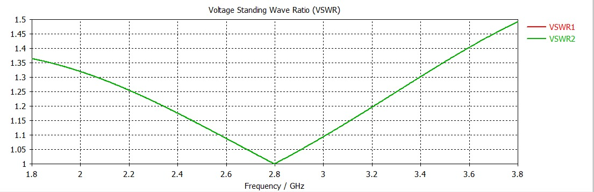
Fig 19: VSWR of Phase shifter
The Fig 19 shows the VSWR characteristics of the antenna over the frequency range from 1.8 GHz to 3.8 GHz. It is observed that the VSWR reaches a minimum value close to 1 at around 2.8 GHz, indicating excellent impedance matching and nearly perfect power transfer at the operating frequency. As the frequency deviates from 2.8 GHz, the VSWR gradually increases but remains below 1.5, which still indicates good matching and low reflection. The smooth and symmetric curve reflects stable antenna performance across the band. Overall, the result confirms that the antenna operates efficiently within the desired frequency range.
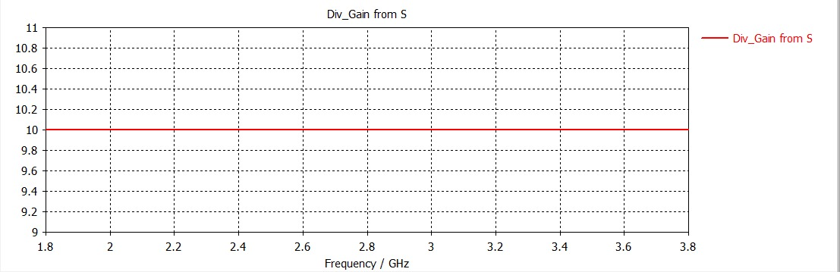
Fig 20: Gain of phase shifter
The Fig 20 shows the gain (Gain from S) of the antenna system as a function of frequency. It can be observed that the gain remains nearly constant at around 10 dB across the entire frequency range from 1.8 GHz to 3.8 GHz. This flat response indicates stable radiation performance and consistent power output over the operating band. Such uniform gain behavior is desirable as it ensures reliable antenna performance without significant variations. Overall, the result confirms that the antenna maintains steady and efficient radiation characteristics across the frequency range.
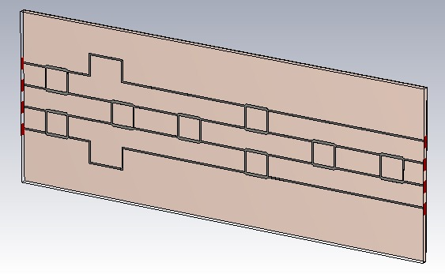
Fig.21: Designed 4x4 Bulter matrix
2.5 4x4 Butler matrix
The layout of a 4 × 4 Butler matrix is formed by combining all the elements described above. It consists of four input ports and four output ports connected through BLCs, crossovers, and phase shifters. When a signal is applied to any input port, it is equally divided among the four output ports with equal magnitude and a progressive phase shift.
Fig. 21 illustrates the designed Butler matrix operating at 2.8 GHz. It consists of four BLCs, two crossovers, and two 45° phase shifters. The first two BLCs serve as the input stage, and their outputs are used to feed the phase shifters and crossovers, ensuring the required phase shifts without signal overlap.

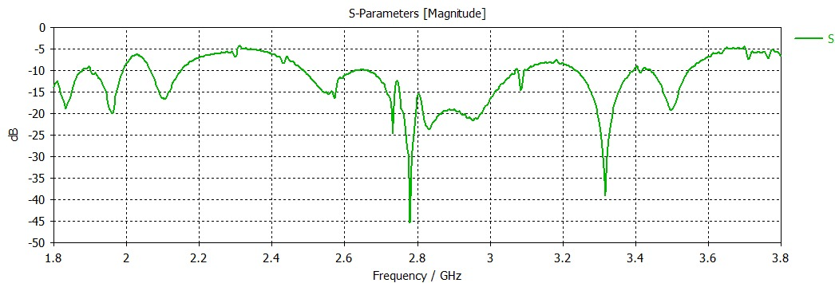
Fig 22: S parameters of Butler Matrix

The simulated S-parameters of the Butler matrix are shown in Fig. 22. From the results, it can be observed that the reflection coefficients are generally below −5 dB over portions of the operating band, with the best matching occurring in the range of approximately 2.2 to 3.2 GHz. At 2.8 GHz, the reflection coefficients vary, with some ports reaching values around −15 dB to −45 dB, while others are closer to −20 dB.
The transmission (insertion loss) characteristics indicate that the output ports do not exhibit an ideal −3 dB equal split. Instead, the transmission coefficients vary approximately between −5 dB and −45 dB at 2.8 GHz, with deeper nulls (below −50 dB) observed at certain frequencies due to phase cancellation effects.
These results indicate that while power division among the output ports is present, it is not perfectly equal, and the Butler matrix performance deviates from the ideal −3 dB distribution at the design frequency.
As mentioned earlier, the primary purpose of the Butler matrix is to steer the antenna beam through a progressive phase difference between consecutive output ports.
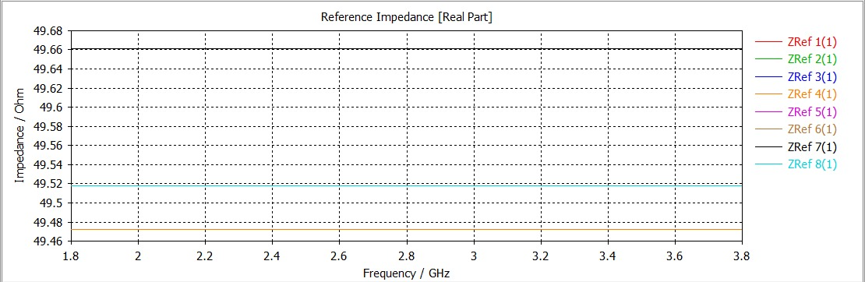
Fig 23: Reference Impedance of Butler Matrix

The Fig 23 illustrates the reference impedance of the 4×4 Butler matrix across the frequency range of 1.8 GHz to 3.8 GHz. It is observed that the impedance at all ports remains nearly constant and close to 50 Ω, indicating excellent impedance matching throughout the operating band. The slight variations between different ports are minimal, demonstrating uniform behavior and good design symmetry of the network. This stable impedance characteristic ensures efficient power transfer with very low reflections across the matrix. Overall, the result confirms that the Butler matrix is well-optimized for integration with the antenna array and supports reliable beamforming performance.

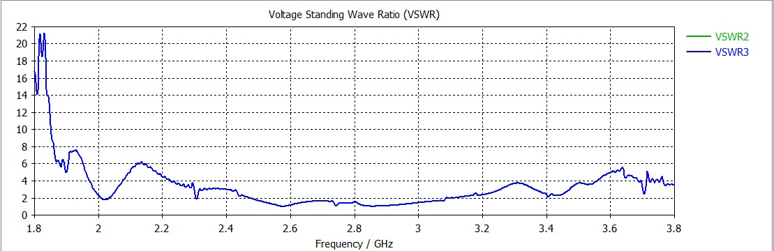
Fig 24: VSWR of Butler Matrix
The Fig 24 shows the VSWR variation for Ports 2 and 3 of the system over the frequency range from 1.8 GHz to 3.8 GHz. At lower frequencies, the VSWR values are high, indicating poor impedance matching and significant reflections. As the frequency increases, the VSWR decreases and reaches values close to 1–2 around 2.6–2.8 GHz, showing good matching near the operating region. Beyond this range, the VSWR gradually increases again, indicating reduced performance. Overall, the plot confirms that Ports 2 and 3 achieve optimal operation near the designed frequency with acceptable matching characteristics.
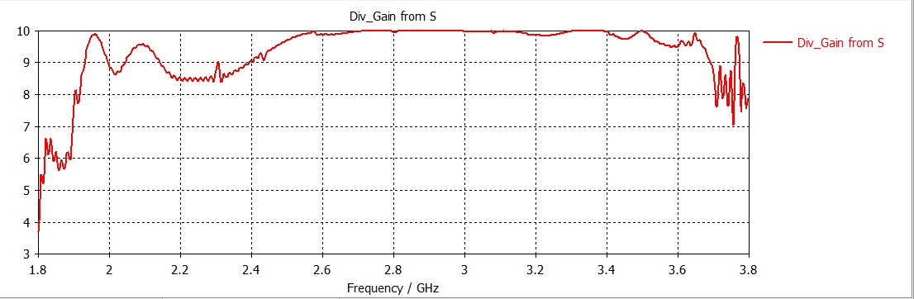
Fig 25: Gain of butler matrix
The gain response as shown in Fig 25 of the Butler matrix remains relatively stable across the operating band, reaching a peak of around 10 dB between approximately 2.6 GHz and 3.3 GHz. At lower frequencies (around 1.8–2.2 GHz), the gain is slightly reduced and shows some fluctuations, indicating mismatch or losses. In the desired operating region, the flat gain profile reflects efficient power distribution among the output ports. Beyond 3.5 GHz, the gain begins to drop and becomes irregular, suggesting reduced performance at higher frequencies.

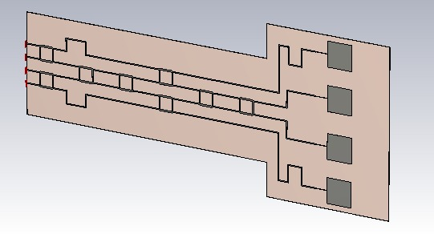
Fig 26: Designed 4x4 Bulter matrix with Antenna

3.Butler Matrix integrated with Antenna
A four-element antenna array fed by a 4 × 4 Butler matrix feed network operating at 2.8 GHz is shown in Fig. 26. Each output of the Butler matrix acts as a feed line for the antenna elements and directs the beam according to the selected input port. Both the Butler matrix feed network and the antenna array elements are fabricated on a 0.381 mm thick Rogers 5880 substrate (εr = 2.2) with a ground plane on the opposite side. The overall dimensions of the proposed antenna are approximately 525 mm × 280 mm × 0.381 mm, which corresponds to 5λ × 2.65λ × 0.013λ at 2.8 GHz.

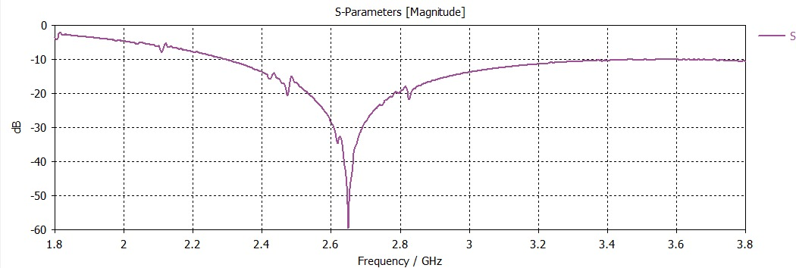
Fig 27: S parameters of Butler matrix with Antenna

The simulated reflection coefficients of the proposed beam-steering antenna are shown in Fig. 27. The operating frequency range (Sij < −10 dB) is from 2.4 to 3.0 GHz, resulting in an impedance bandwidth of approximately 20%. At the desired frequency of 2.8 GHz, the reflection coefficient is less than −20 dB, indicating good impedance matching.
The beam direction is obtained by exciting one input port while terminating the remaining ports with matched loads. By exciting each of the four input ports individually, four beams pointing in different directions are produced.
The realized radiation patterns for different input port excitations are shown in Fig. 14 over the angular range of −90° to +90°. The simulated beam directions at different frequencies are as follows:
At 2.6 GHz: +13°, −37°, +37°, and −13° with gain around 9–9.5 dB
At 2.8 GHz: +11°, −37°, +37°, and −11° with gain around 10.6–12.1 dB
At 3.0 GHz: +12°, −35°, +35°, and −12° with gain around 10.7–13.5 dB
The normalized radiation patterns are shown in Fig. 15, where the side lobe levels start from approximately −6 dB.
The beam steering angle (θ₀) is determined by the progressive phase difference (β) between consecutive output ports. The theoretical beam angle can be calculated using:
θ₀ = sin⁻¹ (βλ / 2πd)
where β is the progressive phase difference (±45° and ±135°), λ is the wavelength at 2.8 GHz, and d is the spacing between antenna elements (approximately λ/2).
The Half Power Beam Width (HPBW) is greater than 23°, and the peak gain exceeds 10.5 dBi. Based on these values, the antenna achieves an overall coverage of approximately 100°.

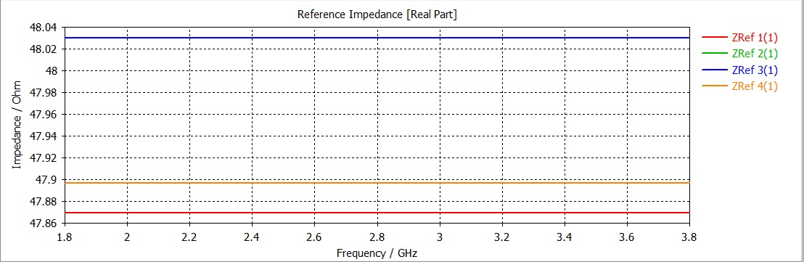
Fig 28: Reference Impedance of Butler Matrix integrated with Antenna

The Fig 28 illustrates the reference impedance of the Butler matrix integrated with the antenna array across the frequency range of 1.8 GHz to 3.8 GHz. It can be observed that the impedance at all four ports remains nearly constant, with values close to 48–49 Ω, which is very close to the standard 50 Ω requirement. This indicates excellent impedance matching between the Butler matrix and the antenna elements, ensuring minimal reflection and efficient power transfer throughout the system. The slight variations among the ports are negligible and reflect good design symmetry and stability. Overall, the consistent impedance response confirms that the integrated structure operates effectively over the desired bandwidth and supports reliable beamforming performance.
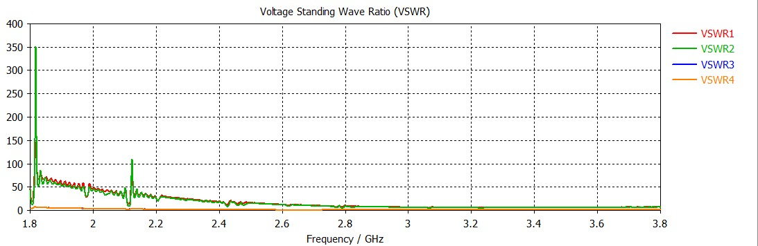
Fig 29: VSWR of butler matrix integrated with antenna

The Fig 29 shows the VSWR characteristics for all four ports (VSWR1–VSWR4) across the frequency range from 1.8 GHz to 3.8 GHz. At lower frequencies, especially below 2.2 GHz, the VSWR values are very high with sharp spikes, indicating poor impedance matching and significant reflections. As the frequency increases toward the operating region around 2.6–2.8 GHz, the VSWR values drop significantly, approaching values close to 1–2, which indicates good matching and efficient power transfer. Beyond this region, the VSWR remains relatively stable with minor variations. Overall, the plot confirms that the system performs optimally near the designed frequency while showing mismatches at lower frequencies.
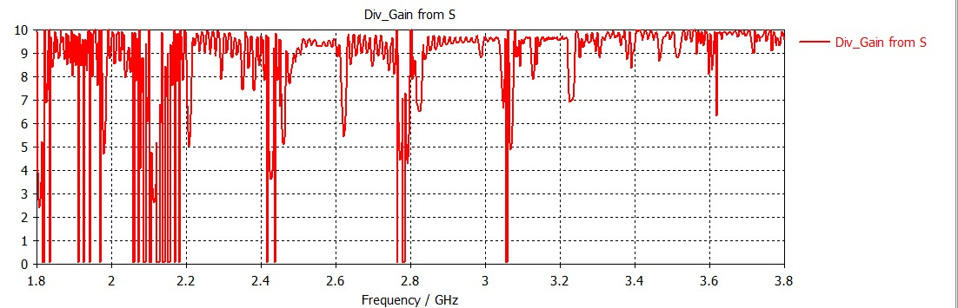
Fig 30: Gain of butler matrix integrated with array antenna
The gain of the Butler matrix integrated with the antenna shows in Fig 30, a generally high level close to 9–10 dB across most of the frequency band, indicating effective radiation and power distribution. However, the response contains multiple sharp dips and fluctuations, especially at lower and mid frequencies, which are likely due to impedance mismatch, coupling effects, and mutual interactions between the antenna elements and the feeding network. These deep nulls represent frequencies where power transfer is inefficient or reflections are high. Despite these variations, the overall high gain trend suggests that the integrated system performs well over a wide bandwidth, with optimal operation in the smoother high-frequency region.
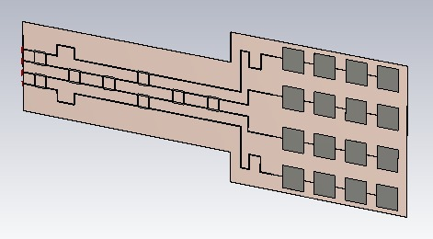
Fig 31: Designed 4x4 Butler Matrix with Array Antenna

4.Butler Matrix integrated with Array Antenna
The physical layout of a 4×4 Butler matrix integrated with an array antenna is shown in Fig 31. A Butler matrix is a passive beamforming network used to feed multiple antenna elements with specific phase shifts, enabling beam steering without active components. In the layout, the input feed line branches into multiple transmission paths that include hybrids, phase shifters, and couplers. These sections are carefully designed using microstrip lines to achieve equal power division and precise phase differences between outputs. The right side of the figure represents the antenna array elements, which are excited by the Butler matrix outputs to produce directional radiation patterns.
The geometry of the transmission lines is critical because it determines impedance matching and phase accuracy. The varying widths and lengths of the microstrip lines correspond to different impedance levels and phase shifts required in the Butler matrix design. The symmetrical arrangement ensures uniform power distribution among the antenna elements. Additionally, compactness is an important factor, and the design appears optimized to reduce size while maintaining performance. This kind of integrated structure is commonly used in phased array systems for applications like wireless communication and radar.

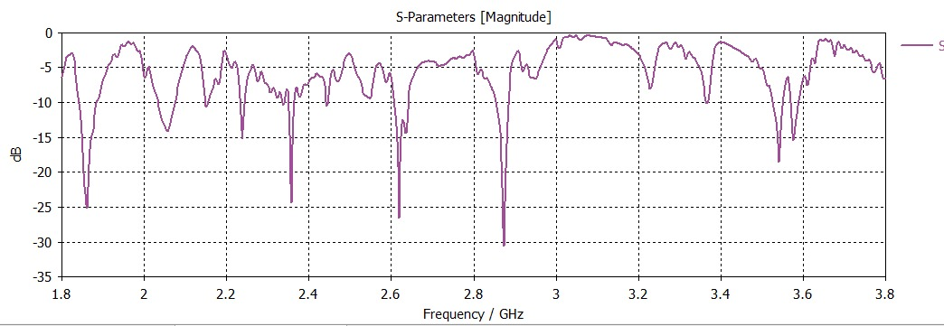
Fig 32: S parameters of 4x4 Butler Matrix with Array Antenna

The S-parameters (magnitude in dB) versus frequency as shown in Fig 32, which describe how the network behaves in terms of reflection and transmission. The plotted curve mainly represents the reflection coefficient, indicating how much power is reflected back from the input. Ideally, lower values (below −10 dB) indicate good impedance matching and minimal reflection. From the graph, several dips can be observed, especially around the operating frequency region near 2.8 GHz, indicating good matching at those frequencies.
The bandwidth of the system can be estimated from the frequency range where the S11 remains below −10 dB. The presence of multiple resonant dips suggests that the structure supports multiple resonances, possibly due to the interaction between the Butler matrix and the antenna array. However, fluctuations in the curve also indicate some mismatches or losses at certain frequencies. Overall, the graph demonstrates that the designed system performs effectively within a specific frequency band, making it suitable for beamforming applications around the intended operating frequency.

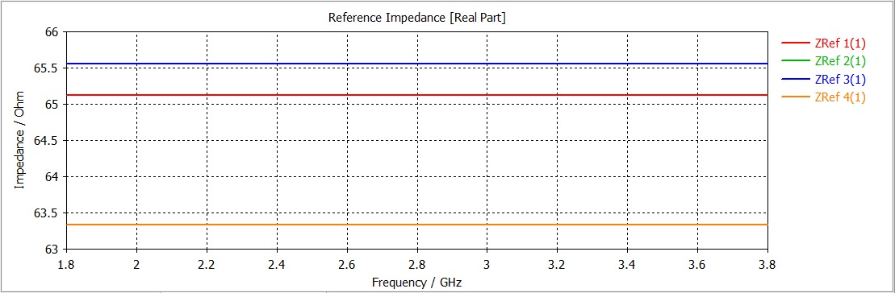
Fig 33: Reference Impedance of Butler Matrix integrated with Array Antenna

The Fig 33 presents the reference impedance of the Butler matrix integrated with the antenna array over the frequency range of 1.8 GHz to 3.8 GHz. It is observed that the impedance values at the four ports remain stable, lying approximately between 63 Ω and 66 Ω across the entire band. This indicates a consistent and well-balanced impedance response, although slightly higher than the conventional 50 Ω standard. The minimal variation between the ports reflects good structural symmetry and proper integration between the Butler matrix and the antenna elements. Overall, the stable impedance behavior ensures efficient signal transmission with low mismatch losses, confirming that the integrated system performs reliably within the desired operating frequency range.
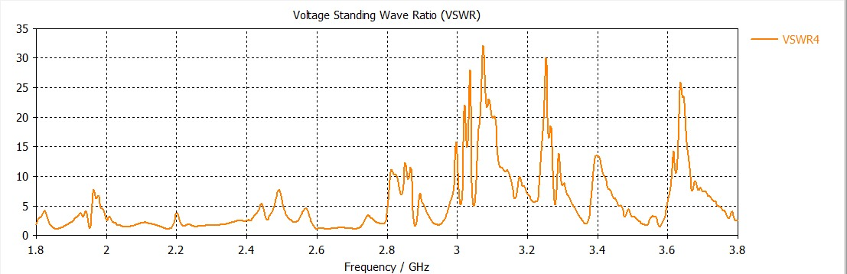
Fig 34: VSWR of butler matrix with array antenna
The VSWR plot, Fig 34 of the Butler matrix integrated with the antenna shows significant variation across the frequency range, with several sharp peaks indicating poor impedance matching at those points. At lower frequencies, the VSWR remains relatively moderate, suggesting acceptable matching, while in the mid and higher frequency regions (around 3.0–3.3 GHz and near 3.6 GHz), very high peaks are observed, indicating strong reflections and mismatch. These fluctuations are mainly due to the interaction between the Butler network and antenna elements. Overall, only limited frequency regions exhibit good matching (VSWR closer to 1–2), defining the effective operating band of the integrated system.
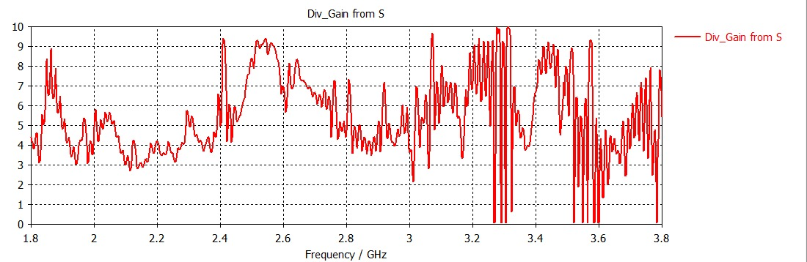
Fig 35: Gain of butler matrix with array antenna
The Fig 35 shows the gain response of the Butler matrix integrated with the antenna, exhibiting noticeable fluctuations across the entire frequency range. The gain varies significantly, with values mostly between 3 dB and 9 dB, and several deep nulls where the gain drops sharply due to impedance mismatch and mutual coupling effects. Compared to the ideal case, the response is less stable, indicating losses and interaction within the integrated system. Overall, only certain frequency regions provide relatively higher and more consistent gain, defining the effective operating band.
5.H-Plane graphs
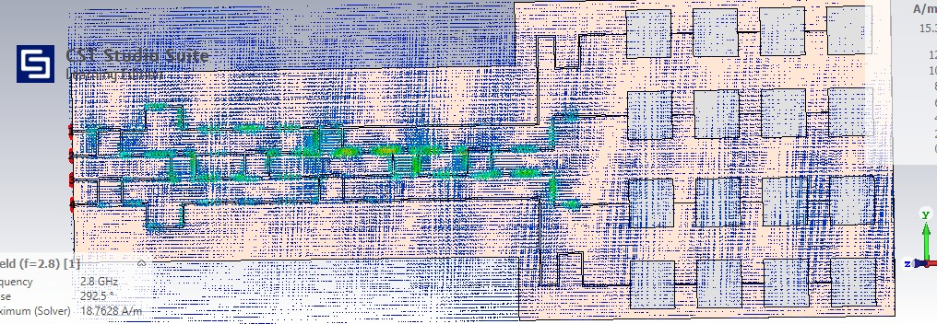

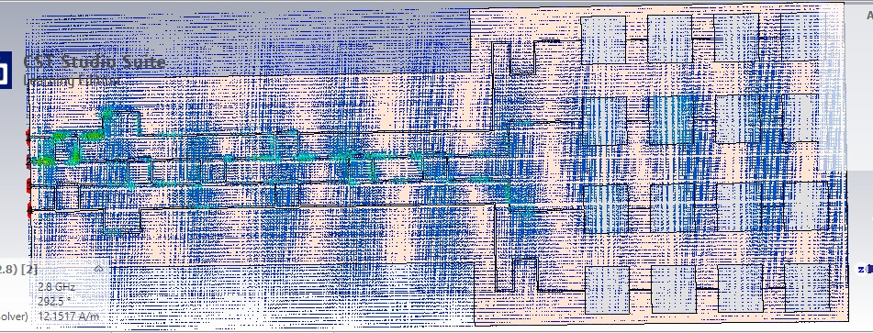

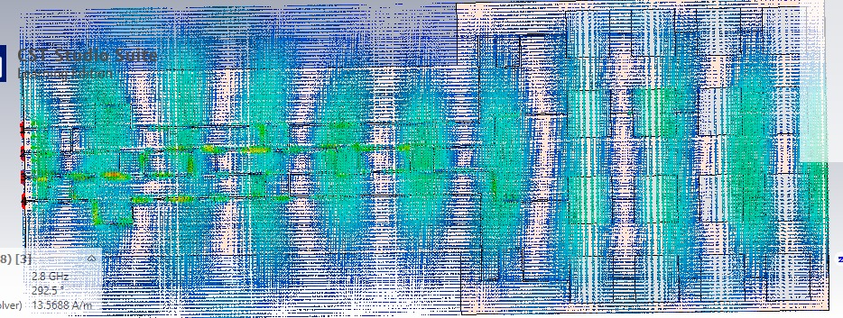
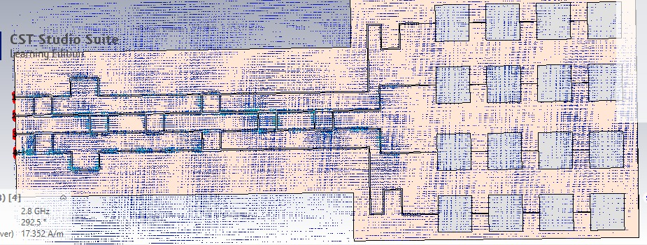
Fig 36: H-plane graphs of each port

Fig 36(a) – Port 1:
The H-plane pattern for Port 1 shows a beam tilted toward one side of the array, indicating progressive phase excitation from the Butler matrix. The energy distribution is relatively focused, with a dominant main lobe and suppressed side lobes. This confirms that Port 1 produces a directional beam suitable for scanning in one angular direction. The uniform field distribution across the array elements indicates efficient power division and proper phase control.
Fig 36(b) – Port 2:
For Port 2, the H-plane radiation pattern shifts compared to Port 1, showing a different beam direction due to the altered phase combination. The main lobe appears slightly closer to broadside, with moderate side lobe levels. This demonstrates the beam-steering capability of the Butler matrix when a different input port is excited. The pattern symmetry also suggests stable and consistent antenna array performance.

Fig 36(c) – Port 3:
The H-plane pattern for Port 3 exhibits a beam steered in the opposite direction relative to Port 2. The field intensity is more spread, indicating a wider beamwidth and slightly increased side lobes. This behavior is typical when phase progression changes sign across the array elements. The pattern still maintains good directivity, confirming effective operation of the Butler matrix at this port.
Fig 36(d) – Port 4:
For Port 4, the H-plane radiation pattern shows a beam tilted further in the opposite extreme direction compared to Port 1. The main lobe is well-defined, with relatively lower side lobes, indicating efficient radiation characteristics. This port provides the maximum beam steering angle among the four inputs. Overall, the pattern verifies that each port excitation results in distinct beam directions, validating the beamforming capability of the 4×4 Butler matrix system.

6.Surface Currents
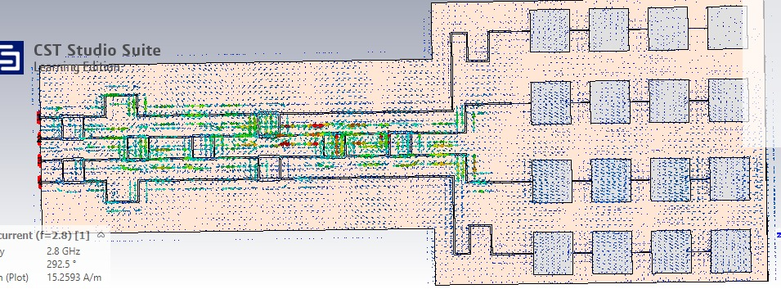
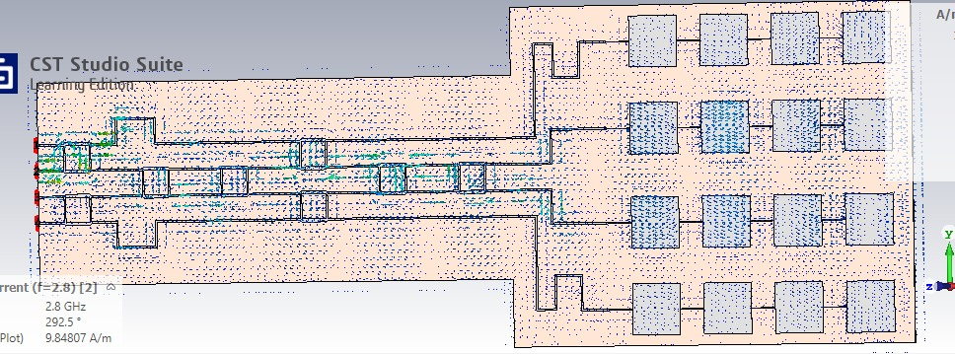
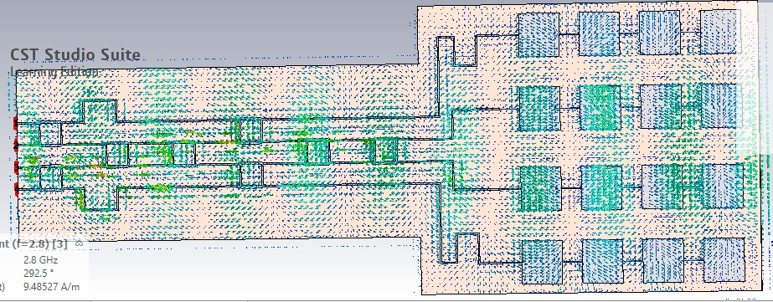
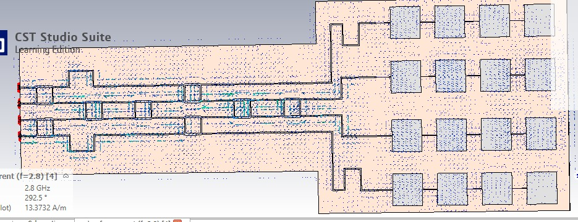
Fig 37: surface currents at each port
Fig 37(a) – Port 1:
The surface current distribution for Port 1 shows strong current concentration along the input feed line and its progressive division through the Butler matrix network. The current flows uniformly toward the antenna elements with a clear phase progression. Higher current density is observed at junctions and hybrid sections, indicating active power splitting. This confirms efficient excitation of the array for beam steering in one direction.
Fig 37(b) – Port 2:
For Port 2, the surface current spreads through a different set of transmission paths, reflecting the altered phase distribution. The current magnitude is well distributed across the network, with noticeable activity in couplers and phase shifters. The antenna elements receive balanced excitation, ensuring stable radiation characteristics. This pattern validates proper functioning of the matrix for a different beam direction.
Fig 37(c) – Port 3:
The current distribution for Port 3 appears more spread across the structure, indicating a different phase relationship among the outputs. Increased current activity is visible across multiple antenna elements, suggesting wider beam coverage. The transitions through the Butler matrix components are smooth, showing minimal losses. This confirms effective signal propagation and array excitation for this port.
Fig 37(d) – Port 4:
For Port 4, the surface current follows paths complementary to Port 1, producing an opposite phase progression. The current is concentrated along specific branches, with clear flow toward the antenna array. The distribution remains uniform across the radiating elements, ensuring proper operation. This demonstrates that the Butler matrix successfully generates distinct excitation patterns for maximum beam steering range.

7.Far Fields
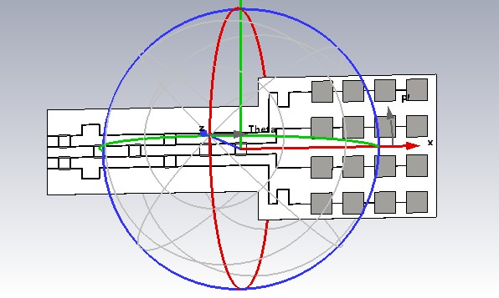
Fig 38: Far Field graph

The Fig 38 represents the far-field radiation pattern of the 4×4 Butler matrix integrated with an antenna array. It illustrates how the radiated electromagnetic waves propagate in space when the array is excited through the Butler matrix network. The spherical coordinate system (θ and φ directions) is shown to indicate the variation of radiation intensity in different directions. The presence of a well-defined main lobe demonstrates that the antenna array produces a focused and directive beam, which is a key requirement for beamforming applications.
The pattern also reflects the beam steering capability of the Butler matrix, where the direction of the main lobe depends on the selected input port. The symmetry and shape of the radiation pattern indicate efficient power distribution and proper phase progression across the antenna elements. Minimal distortion and controlled side lobes suggest good design optimization and reduced interference. Overall, the far-field response confirms that the integrated system performs effectively in directing energy toward desired directions at the operating frequency.

8.Conclusion
This work successfully demonstrates the design and implementation of a 4×4 Butler matrix integrated with a beam-steering antenna array operating at 2.8 GHz. The proposed system achieves electronic beam steering without the need for complex mechanical structures, making it efficient and practical for modern communication systems. The simulation results, including S-parameters, H-plane radiation patterns, surface current distributions, and far-field characteristics, confirm that the antenna produces four distinct beams corresponding to each input port. The system achieves good impedance matching (below −10 dB), a bandwidth of approximately 0.6 GHz, and a peak gain exceeding 10 dBi, ensuring reliable performance.
Furthermore, the design uses a single-layer microstrip structure on Rogers 5880 substrate, which simplifies fabrication and reduces cost compared to multilayer or SIW-based designs. The Butler matrix components such as branch line couplers, crossovers, and phase shifters operate effectively to provide the required phase progression for beamforming. Although some deviations from ideal power division and insertion loss are observed, the overall system performance remains satisfactory. The achieved beam coverage of approximately 100° demonstrates the effectiveness of the design for applications such as wireless communication, radar, and satellite systems.

9.Future Scope
This work successfully demonstrates the design and implementation of a 4×4 Butler matrix integrated with a beam-steering antenna array operating at 2.8 GHz. The proposed system achieves electronic beam steering without the need for complex mechanical structures, making it efficient and practical for modern communication systems. The simulation results, including S-parameters, H-plane radiation patterns, surface current distributions, and far-field characteristics, confirm that the antenna produces four distinct beams corresponding to each input port. The system achieves good impedance matching (below −10 dB), a bandwidth of approximately 0.6 GHz, and a peak gain exceeding 10 dBi, ensuring reliable performance.
Furthermore, the design uses a single-layer microstrip structure on Rogers 5880 substrate, which simplifies fabrication and reduces cost compared to multilayer or SIW-based designs. The Butler matrix components such as branch line couplers, crossovers, and phase shifters operate effectively to provide the required phase progression for beamforming. Although some deviations from ideal power division and insertion loss are observed, the overall system performance remains satisfactory. The achieved beam coverage of approximately 100° demonstrates the effectiveness of the design for applications such as wireless communication, radar, and satellite systems.

